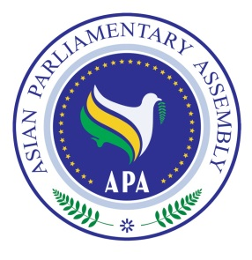
Asian Parliamentary Assembly
The 11th Plenary Session

Standing Committee on Economic and Sustainable Development

30 November 2018

Istanbul – Turkey

Draft Agenda
1- Adoption of the Agenda
2- Election of the Bureau
3- Opening Remarks by Chairperson of the Meeting
4- Report by H.E. Dr. Ali Khorram, Deputy Secretary General of APA
5- Consideration of Draft Resolutions recommended by the Executive Council
6- Any other matters.

As of 27 November 2018

